Project Time Management

Schedule Management plan

Here is the screenshot of gantt chart of our project

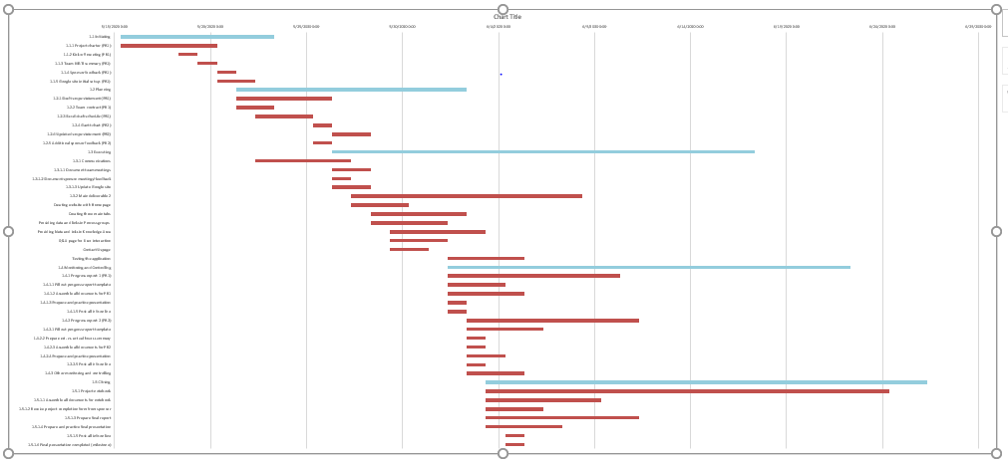

Gantt chart file is attached with the document